PS4_answer

Problem 6

(a). Simulation A: birth prob > death prob.

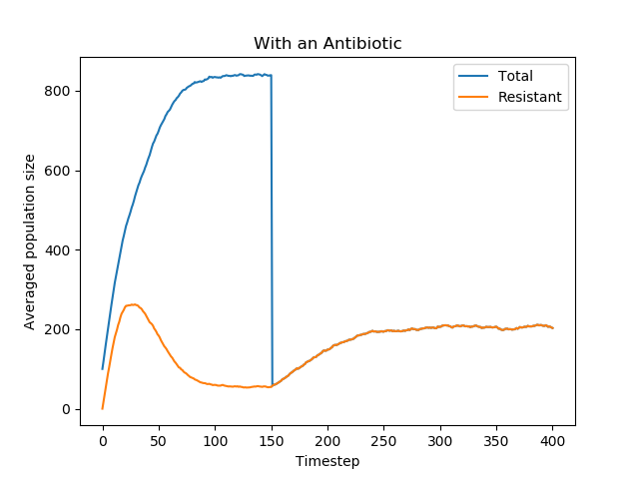

(b). Simulation B: prob < death prob

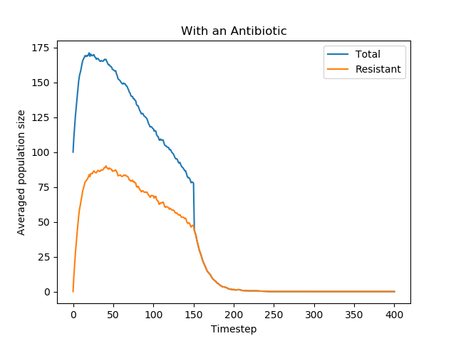

(1). Before introducing the antibiotic, the total population in simulation A increases in a decreasing speed and reaches maximum finally.

Before introducing the antibiotic, the total population in simulation B increases and reaches maximum rapidly. After getting the maximum, the total population start decreasing in a certain rate mainly because of a higher death rate than birth rate in simulation B.

(2). Before introducing the antibiotic, the resistant bacteria population increases at first and then decreases gradually in both A and B.

(3). After introducing the antibiotic, the total population in simulation A increases in a decreasing speed and reaches maximum finally. The total population after introducing antibiotic is much less than the total population before introducing it.

After introducing the antibiotic, the total population in simulation decreases gradually and finally reaches 0 because death rate is higher than birth rate in simulation B.

(4).

The behavior of resistant bacteria population is as the same as total population since only bacteria with resistance can survive in an antibiotic environment.